# [**Mariska Hargitay and Christopher Meloni have a mini Law & Order: SVU reunion ahead of Stabler's return**](https://ew.com/tv/mariska-hargitay-christopher-meloni-svu-reunion/?amp=true&utm_campaign=entertainmentweekly_entertainmentweekly&utm_content=new&utm_medium=social&utm_source=twitter.com&utm_term=5f15bad9502a3e0001d63236&__twitter_impression=true&s=09)

The actors snapped a photo together before heading back to work on the long-running series and Meloni's new spin-off, *Law & Order: Organized Crime*.

[Ruth Kinane](https://ew.com/author/ruth-kinane/)

July 20, 2020 at 11:34 AM EDT

Even commanding officers need some sun before they get down to business.

On Sunday, [Mariska Hargitay](https://ew.com/tag/mariska-hargitay/) and [Christopher Meloni](https://ew.com/tag/christopher-meloni/) shared photos on Instagram of them spending some quality time together. The actors, who previously shared the small screen playing Olivia Benson and Elliot Stabler on *Law & Order: Special Victims Unit* from the show's first season until the end of season 12, are set to reunite in the fall for a more official reunion when Meloni is set to appear on the season 22 premiere of the long-running series.

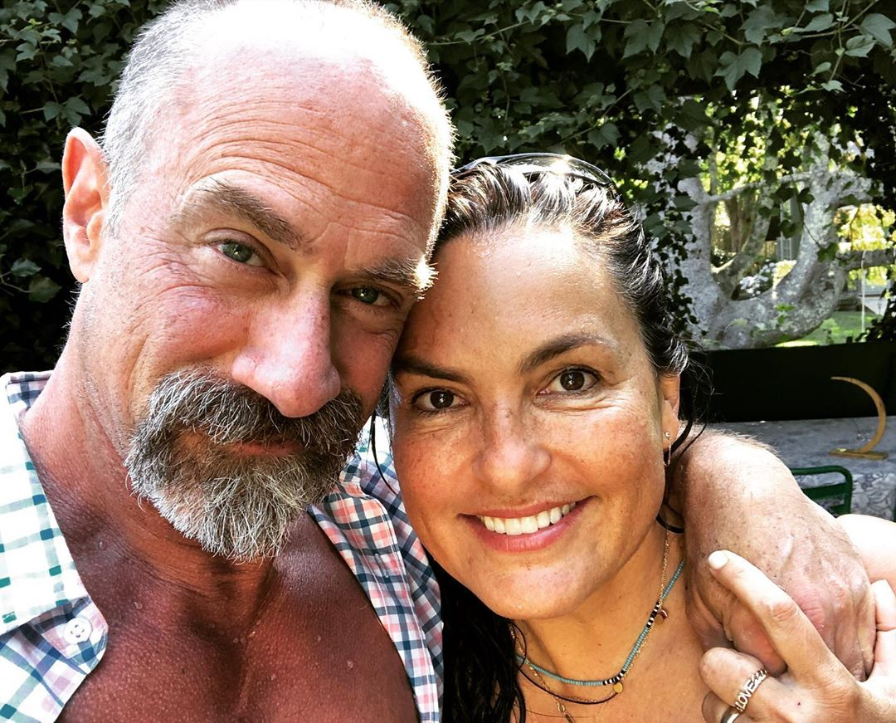

Back in March, it was announced that Meloni's character would be [returning for a new spin-off series](https://ew.com/tv/christopher-meloni-elliot-stabler-return-law-and-order-svu-spinoff/), a 13-episode drama that is said to revolve around Stabler leading an NYPD organized crime unit. Not much else is known about the new series — titled *Law & Order: Organized Crime —* other than *Chicago P.D.*'s Matt Olmstead is reportedly being eyed to write and showrun.

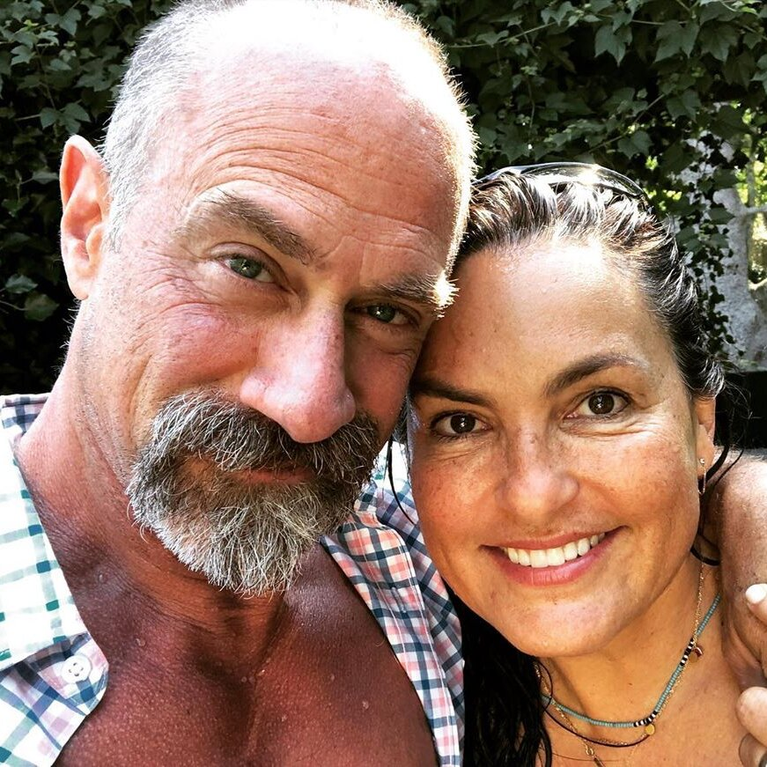

Mariska Hargitay/Instagram

When Meloni left *SVU* after 12 seasons, Stabler was written off as retiring from the force, while Benson rose to head the whole division. With a new show in the works, clearly something has enticed Stabler to return to the fray, but first, the character is set to stop by his old stomping grounds for a crossover episode or two before setting up shop at a new precinct. "We're going to reintroduce my character, Elliott Stabler, and give the audience the backstory of where he's been, how he's been, and he's going to rejoin the NYPD, but with the organized crime unit," the actor [told EW recently](https://ew.com/tv/christopher-meloni-law-and-order-return-maxx/).